Ideation Phase
Brainstorm & Idea Prioritization Template

Date | 25 September 2026
Team ID | SWTID-2026-4039
Project Name | AI Weather Wise
Maximum Marks | 4 Marks

Brainstorming & Idea Prioritization Template
Brainstorming fosters an open, collaborative environment where team members can freely explore innovative AI-driven weather solutions, prioritizing a high volume of creative ideas over initial perfection. By leveraging this template, teams can uncover breakthrough concepts—ranging from AI predictive forecasting to extreme weather early-warning systems—and effectively prioritize them based on technical feasibility and impact, even while working remotely.
Step-1: Team Gathering, Collaboration and Select the Problem Statement
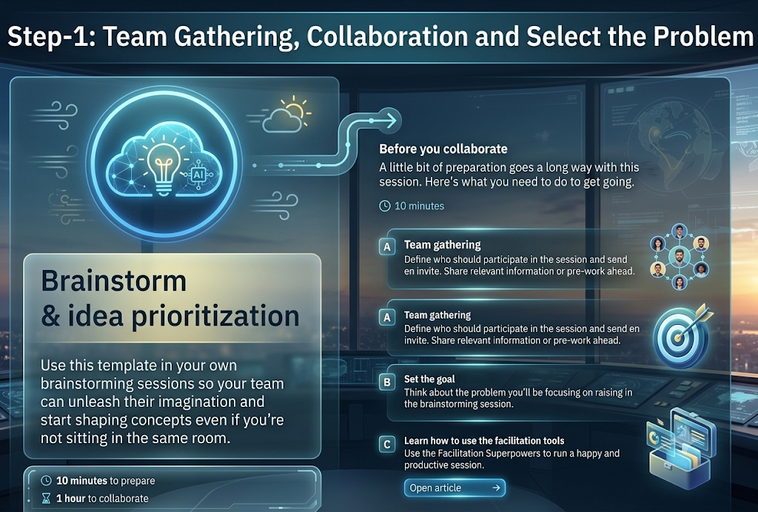

Step-2: Brainstorm, Idea Listing and Grouping
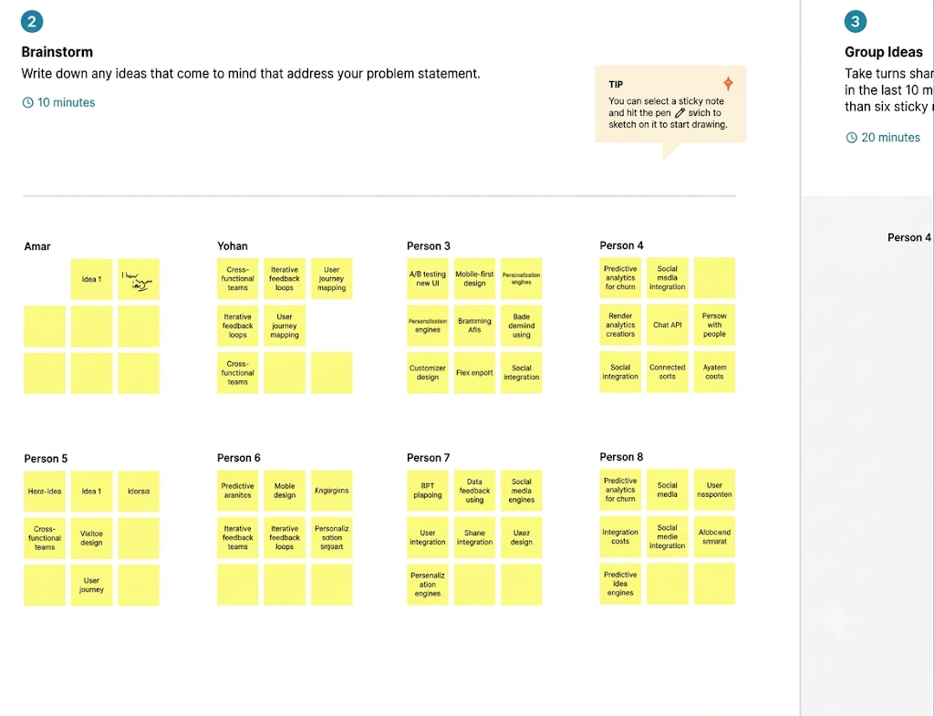

Step-3: Idea Prioritization
